Installing Knative Functions
Installing the func CLI
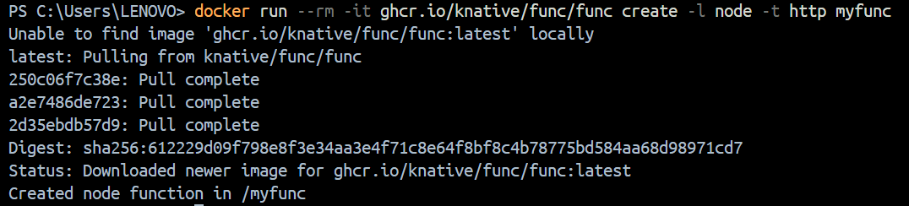

create a function project by using the func CLI
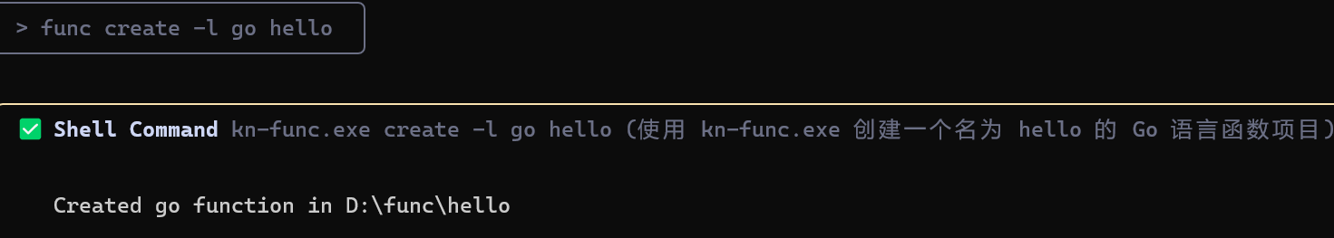

Running a function
Run the function locally by running the command inside the project directory.
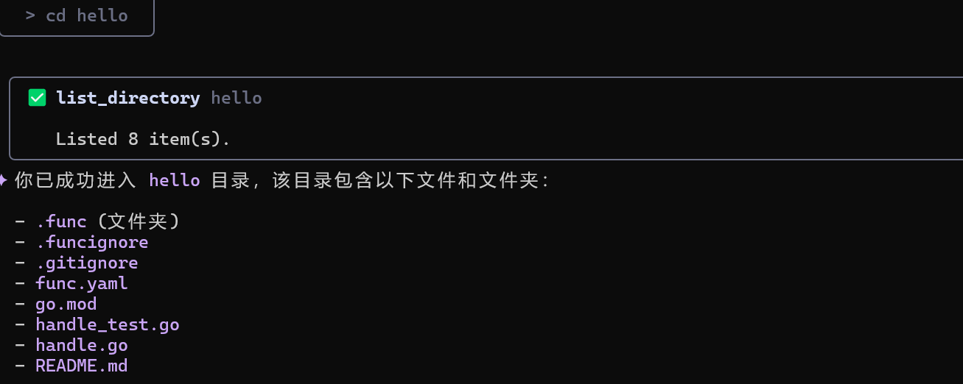

Run the function locally by running the command inside the project directory.
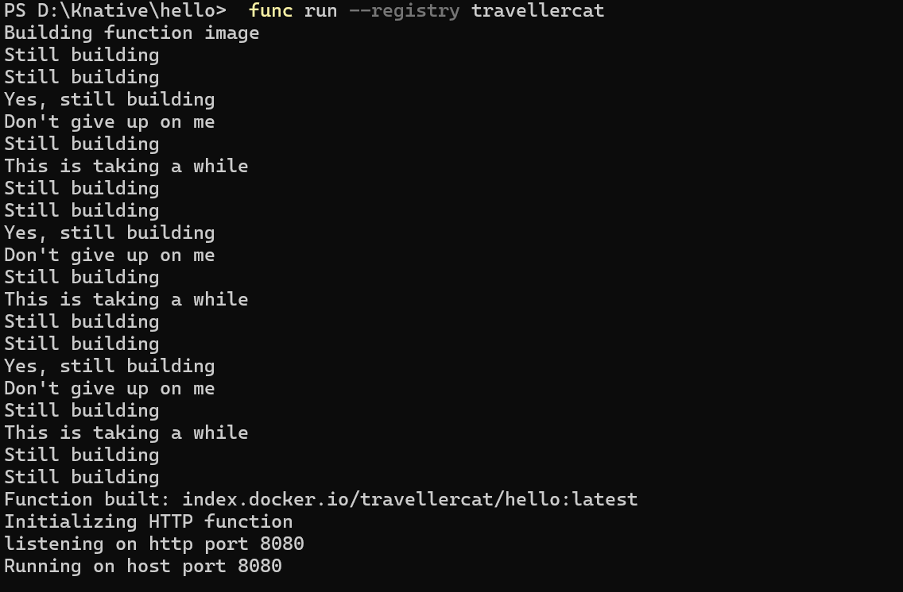

verify that your function has been successfully run by using the invoke command and observing the output:

Deploying a Knative Service
Run the Knative quickstart plugin
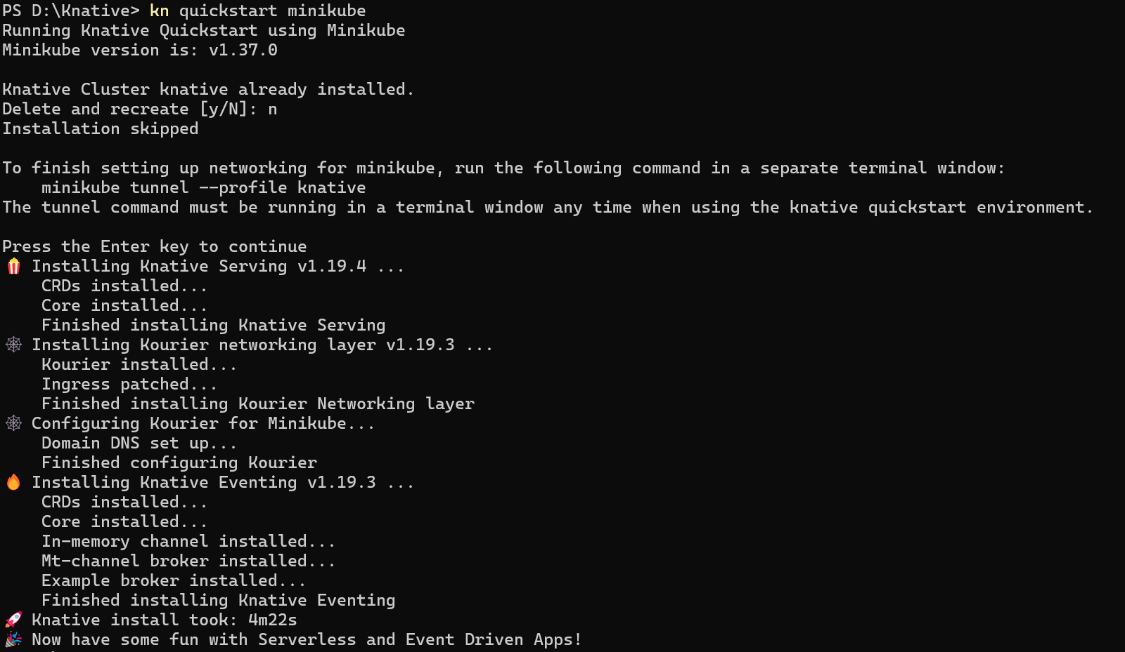

run the following command to start the process in a secondary terminal window
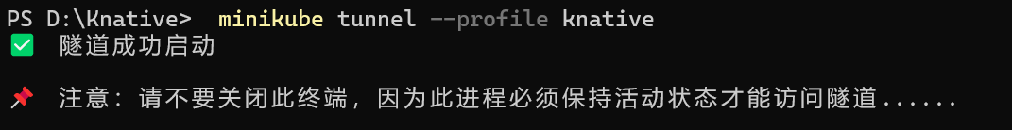

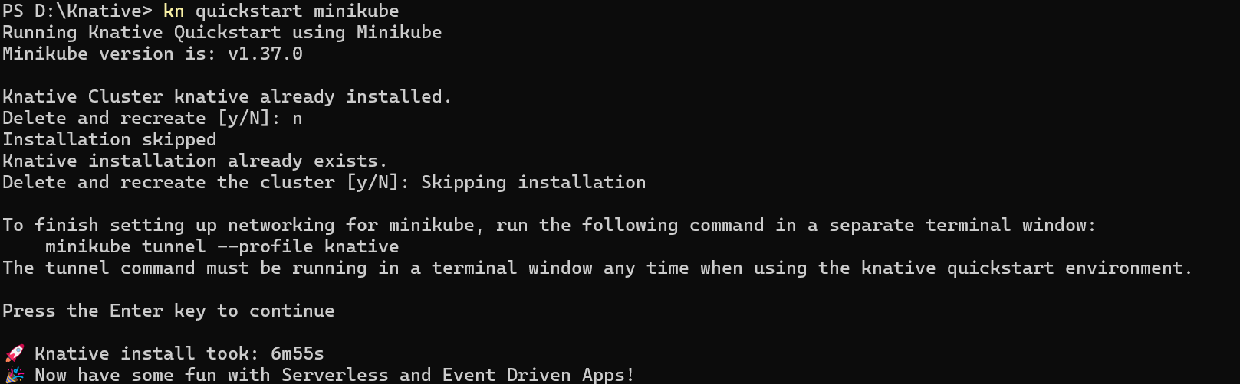

Deploy the Service by running the command
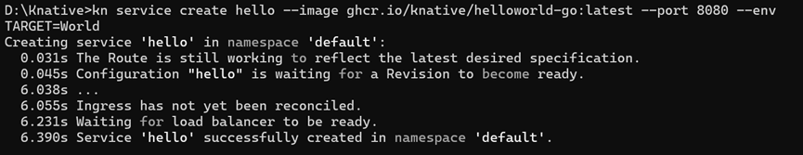

View a list of Knative Services by running the command:
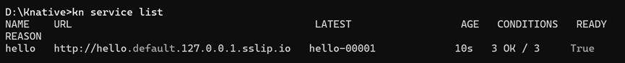

Access your Knative Service by opening the previous URL in your browser or by running the command:
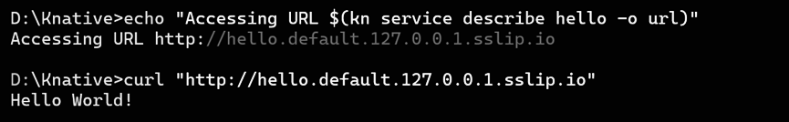

Watch the pods and see how they scale to zero after traffic stops going to the URL:
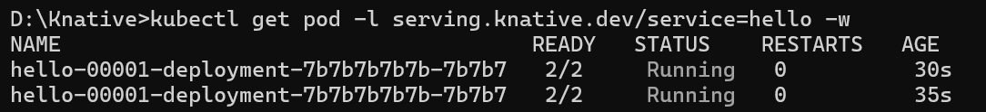

Traffic splitting
Creating a new Revision
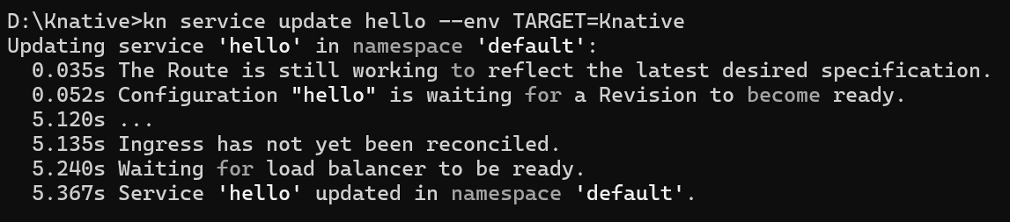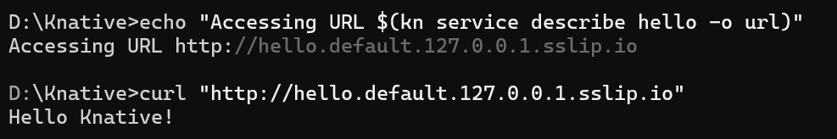

View a list of revisions by running the command:
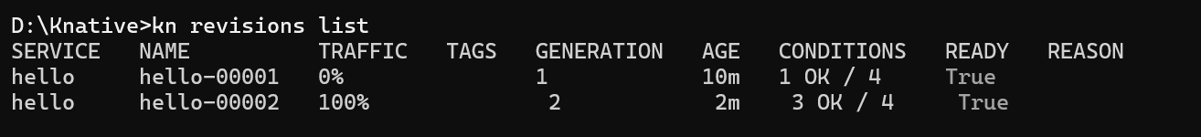

Splitting traffic between Revisions
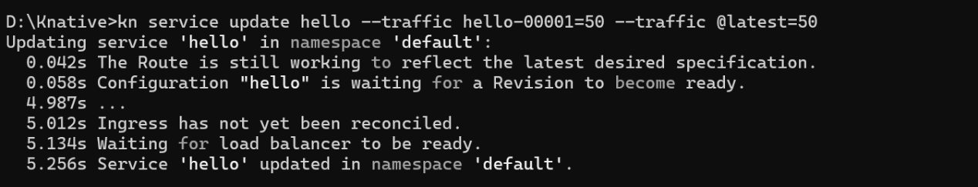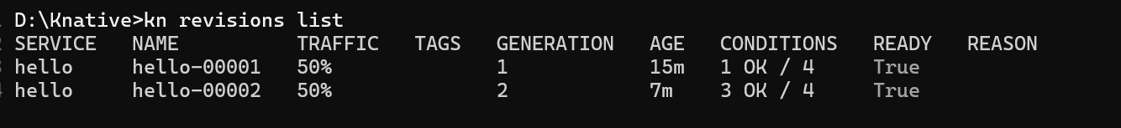

Knative Eventing¶
Verify that the Broker is installed by running the following command:
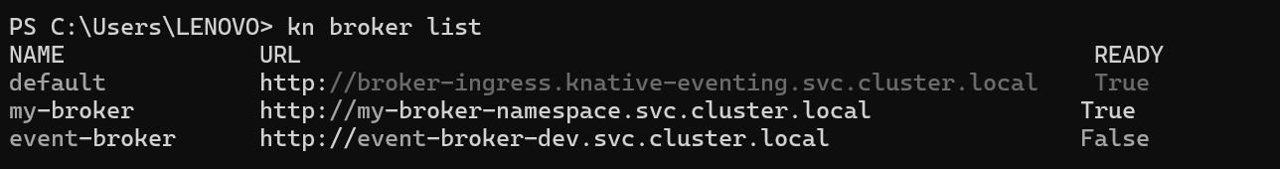

Creating your first source
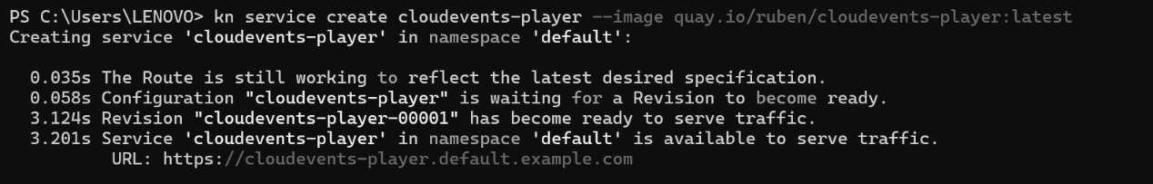
create a SinkBinding between the service and the broker.
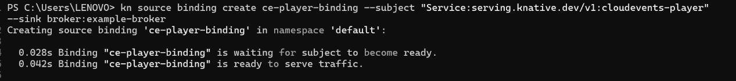

Sending an event
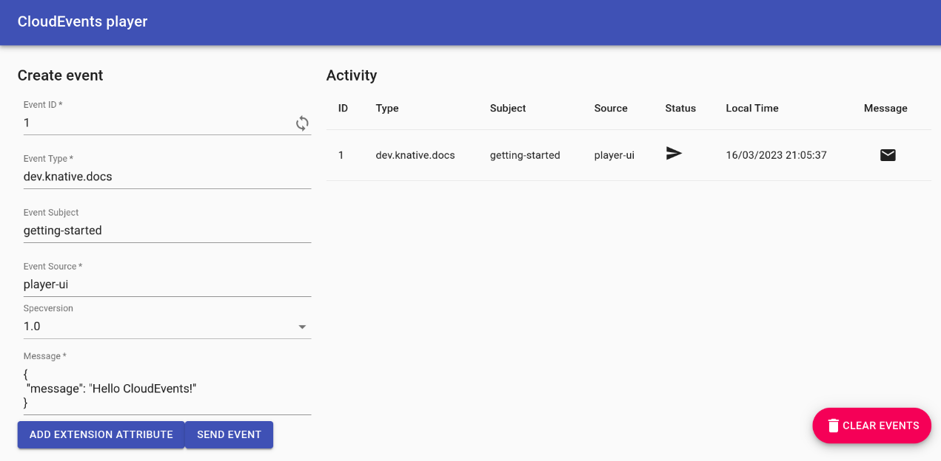

Using Triggers and sinks
create the Trigger
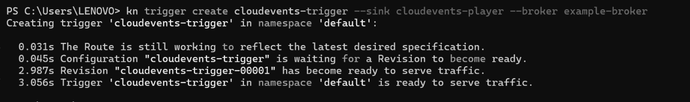

go back to the CloudEvents Player and send an event
